#
# 20190809
# SD#3026304

https://stash.tcsbank.ru/projects/UNIX/repos/linux_pcidss/browse?at=refs%2Ftags%2F1.0.0

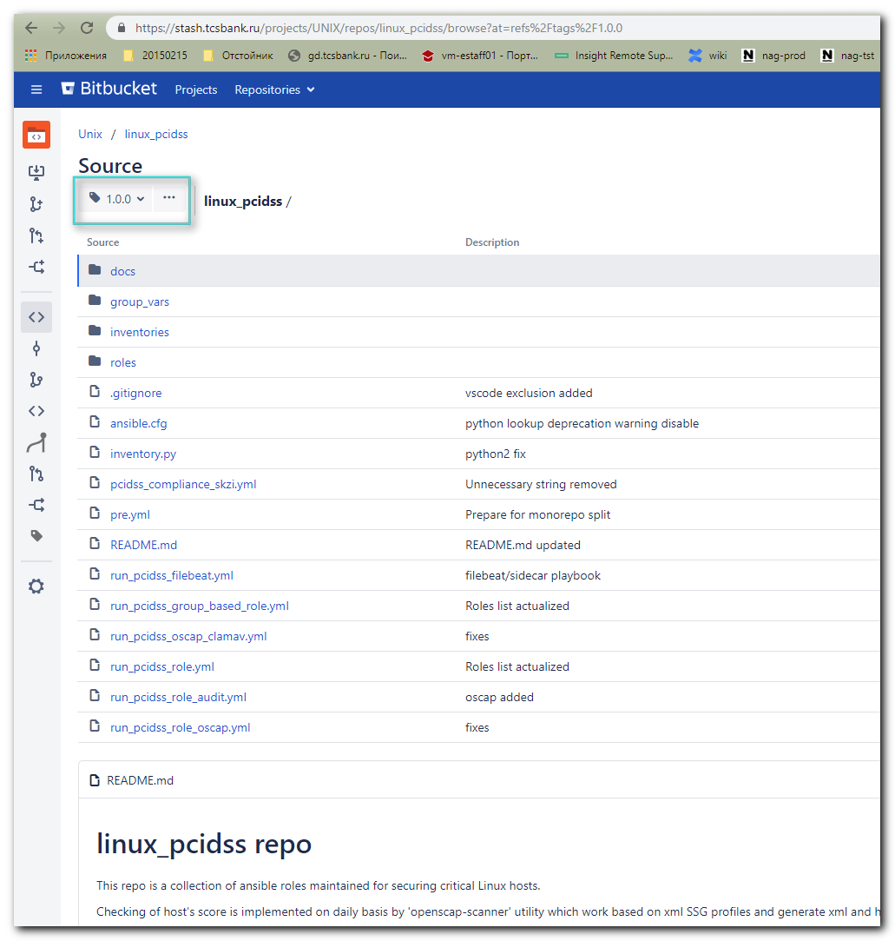

#
# Here is a link to clone this repository.
#
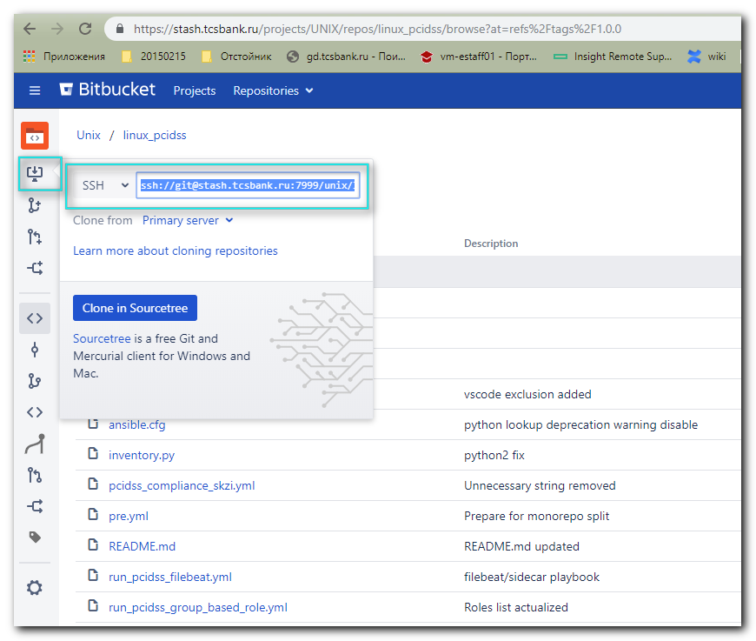

[support@centos 20190809-1729]$ git clone ssh://git@stash.tcsbank.ru:7999/unix/linux_pcidss.git
Cloning into 'linux_pcidss'...
remote: Counting objects: 1100, done.
remote: Compressing objects: 100% (874/874), done.
remote: Total 1100 (delta 524), reused 114 (delta 17)
Receiving objects: 100% (1100/1100), 3.80 MiB | 1.03 MiB/s, done.
Resolving deltas: 100% (524/524), done.
[support@centos 20190809-1729]$ git branch
fatal: Not a git repository (or any of the parent directories): .git
[support@centos 20190809-1729]$ ll
total 4
drwxrwxr-x 7 support support 4096 Aug 9 17:31 linux_pcidss
[support@centos 20190809-1729]$ cd linux_pcidss/
[support@centos linux_pcidss]$

[support@centos linux_pcidss]$ git tag
1.0.0
[support@centos linux_pcidss]$

[support@centos linux_pcidss]$ git checkout tags/1.0.0
HEAD is now at 1dc305b... README.md updated
[support@centos linux_pcidss]$

[support@centos linux_pcidss]$ git status
# HEAD detached at 1.0.0
nothing to commit, working directory clean
[support@centos linux_pcidss]$

#
# Here is how apply pci dss policies.
#

# This version of ansible playbook works correctly with ansible version 2.7.x or higher.
#
[support@centos linux_pcidss]$ ansible --version | grep "^ansible"
ansible 2.8.2
[support@centos linux_pcidss]$

[support@centos linux_pcidss]$ cat list_of_hosts
[PCI_DSS]
# ds-pr-eacq-mapi-pf01p
m1-pr-eacq-mapi-pf01p
[support@centos linux_pcidss]$

[support@centos linux_pcidss]$ ansible-playbook pcidss_compliance_skzi.yml -i list_of_hosts --become --extra-vars "ansible_user=bsv ansible_password=$(pass common/linux) ansible_sudo_pass=$(pass common/linux) ansible_ssh_common_args='-oStrictHostKeyChecking=no -oPubkeyAuthentication=no'"
BECOME password:

PLAY [all] ************************************************************************************************************************************************************************************************

TASK [Gathering Facts] ************************************************************************************************************************************************************************************
ok: [m1-pr-eacq-mapi-pf01p]
...

#
# 20190829
# I’ve added one the file into git exclusions.
#

[support@centos linux_pcidss]$ cat .git/info/exclude
# git ls-files --others --exclude-from=.git/info/exclude
# Lines that start with '#' are comments.
# For a project mostly in C, the following would be a good set of
# exclude patterns (uncomment them if you want to use them):
# *.[oa]
# *~
list_of_hosts
[support@centos linux_pcidss]$

#
# 20190829
# Try to apply pci dss role.
#
[support@centos linux_pcidss]$ pwd
/home/support/work/20190809-1729.linux_pcidss/linux_pcidss
[support@centos linux_pcidss]$

[support@centos linux_pcidss]$ git pull origin master
From ssh://stash.tcsbank.ru:7999/unix/linux_pcidss
* branch master -> FETCH_HEAD
Updating 1dc305b..bf27b17
Fast-forward
CHANGELOG.md | 28 ++++++++++++++++++++++++++++
README.md | 33 ++++++++++++++++++++++++++++++---
inventories/stage | 8 ++++----
inventory.py | 4 +++-
run_pcidss_role.yml => pcidss.yml | 7 ++-----
pcidss_compliance_skzi.yml | 8 ++++----
run_pcidss_group_based_role.yml => pcidss_group_based.yml | 9 ++++-----
pre.yml | 10 +++++-----
requirements.txt | 2 ++
roles/auditrules/handlers/main.yml | 5 +----
roles/auditrules/templates/99-audit.conf.j2 | 2 +-
roles/clamav/meta/main.yml | 1 +
roles/clamav/tasks/main.yml | 7 +++++--
roles/oscap/files/sos_plugins/clamav.py | 11 +++++++++++
roles/oscap/files/{ => sos_plugins}/passwd.py | 0
roles/oscap/files/ssg-CentOS6-ds-tailoring.xml | 4 ++--
roles/oscap/files/ssg-CentOS7-ds-tailoring.xml | 4 ++--
roles/oscap/files/ssg-OracleLinux6-ds-tailoring.xml | 4 ++--
roles/oscap/files/ssg-OracleLinux7-ds-tailoring.xml | 4 ++--
roles/oscap/files/ssg-RedHat6-ds-tailoring.xml | 4 ++--
roles/oscap/files/ssg-RedHat7-ds-tailoring.xml | 4 ++--
roles/oscap/tasks/main.yml | 12 ++++++++++--
roles/oscap/templates/run_scap-scanner.Debian16.sh.j2 | 2 +-
roles/oscap/templates/run_scap-scanner.Debian18.sh.j2 | 2 +-
roles/oscap/templates/run_scap-scanner.RedHat6.sh.j2 | 2 +-
roles/oscap/templates/run_scap-scanner.RedHat7.sh.j2 | 2 +-
roles/oscap/templates/run_scap-scanner.sh.j2 | 2 +-
roles/pci_boot/tasks/main.yml | 5 ++---
roles/pci_files/tasks/main.yml | 45 ++++++++++++++++++++++-----------------------
run_pcidss_filebeat.yml | 12 ------------
run_pcidss_oscap_clamav.yml | 13 -------------
run_pcidss_role_audit.yml | 10 ----------
run_pcidss_role_oscap.yml | 5 -----
33 files changed, 152 insertions(+), 119 deletions(-)
create mode 100644 CHANGELOG.md
rename run_pcidss_role.yml => pcidss.yml (58%)
rename run_pcidss_group_based_role.yml => pcidss_group_based.yml (80%)
create mode 100644 requirements.txt
create mode 100644 roles/oscap/files/sos_plugins/clamav.py
rename roles/oscap/files/{ => sos_plugins}/passwd.py (100%)
delete mode 100644 run_pcidss_filebeat.yml
delete mode 100644 run_pcidss_oscap_clamav.yml
delete mode 100644 run_pcidss_role_audit.yml
delete mode 100644 run_pcidss_role_oscap.yml
[support@centos linux_pcidss]$

[support@centos linux_pcidss]$ git tag
1.0.0
1.1.1
1.1.2
[support@centos linux_pcidss]$ git checkout tags/1.0.0
Previous HEAD position was bf27b17... Fix shell command and file perms for ubuntu
HEAD is now at 1dc305b... README.md updated
[support@centos linux_pcidss]$
[support@centos linux_pcidss]$ git status
# HEAD detached at 1.0.0
nothing to commit, working directory clean
[support@centos linux_pcidss]$

#
# At this moment everything were applied successfuly.
#
[support@centos linux_pcidss]$ ansible-playbook pcidss_compliance_skzi.yml -i list_of_hosts --become --extra-vars "ansible_user=bsv ansible_password=$(pass common/linux) ansible_sudo_pass=$(pass common/linux) ansible_ssh_common_args='-oStrictHostKeyChecking=no -oPubkeyAuthentication=no'"
...
PLAY RECAP ************************************************************************************************************************************************************************************************
ds-pg-apg01p : ok=102 changed=54 unreachable=0 failed=0 skipped=22 rescued=0 ignored=0
m1-pg-apg01p : ok=102 changed=54 unreachable=0 failed=0 skipped=22 rescued=0 ignored=0

[support@centos linux_pcidss]$

